**6. FUNCTIONS OF SYSTEM:-**

6.1 Use-case diagram(USER)

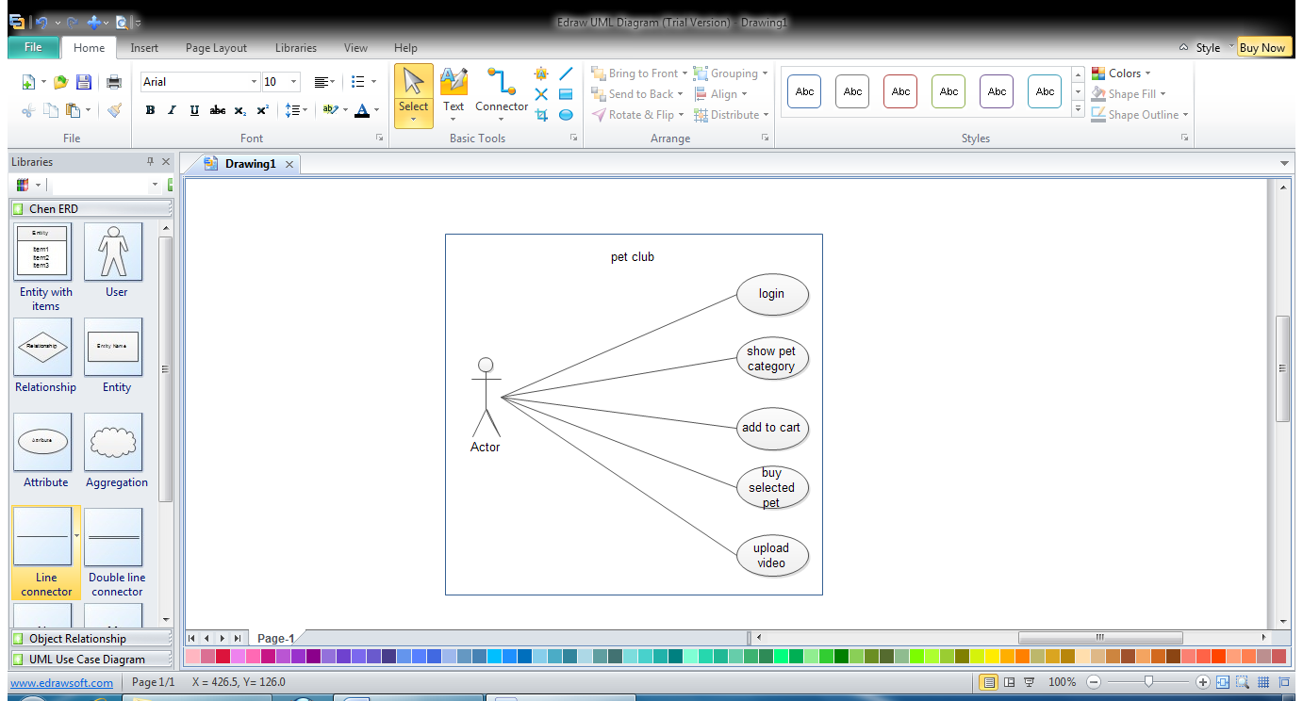

6.1.1 Use-case diagram (ADMIN)

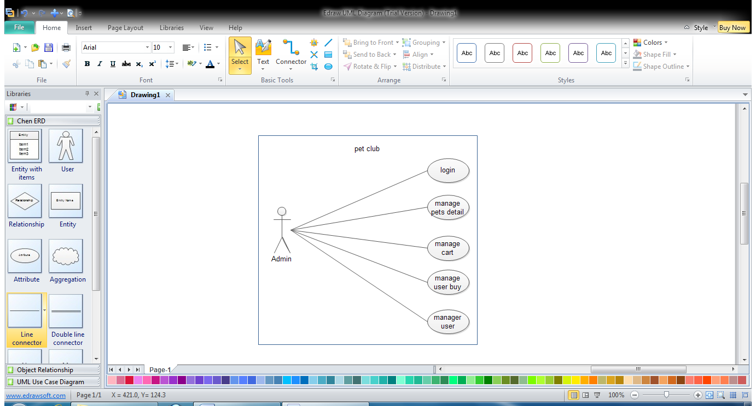

**6.2 DATA MODELING:-**

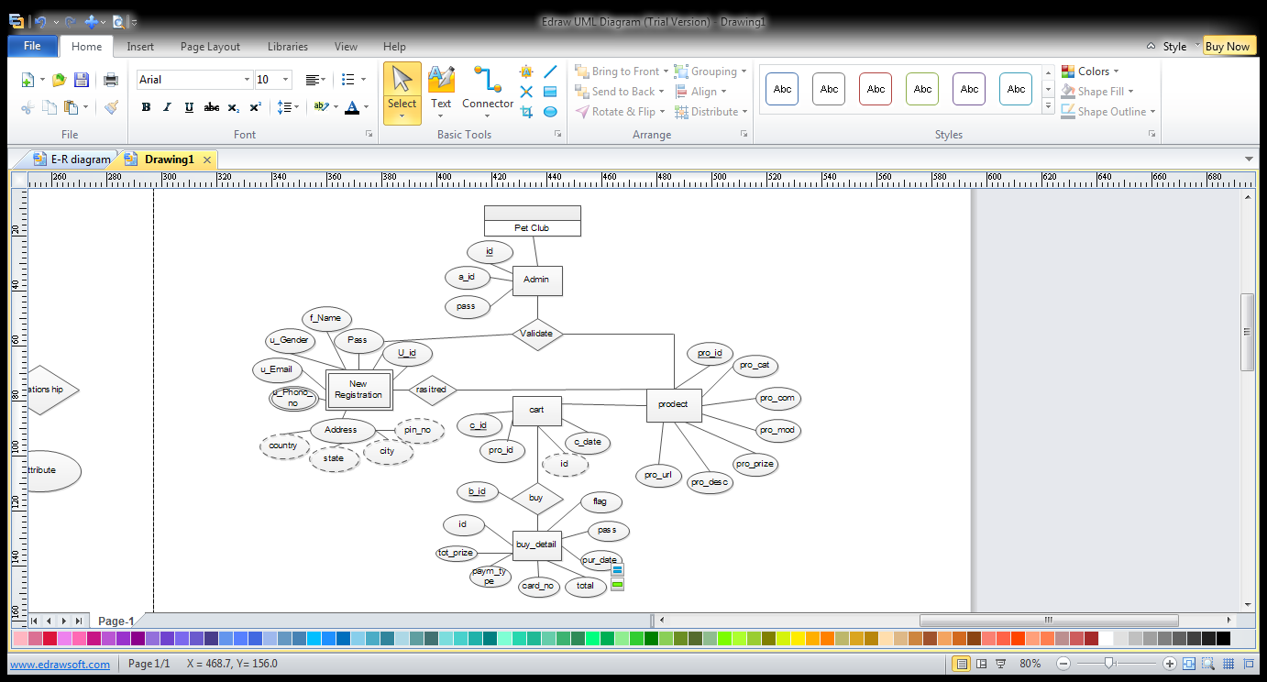**6.2.1 ER Diagram:-**

**6.3 FUNCTIONAL AND BEHAVIROL MODELING:-**

**6.3.1 Context diagram:-**

This system will be scaled up in term of functionality to provide complete visualization environment. To be able to do this system architecture should be scalable to accommodate additional functionality and satisfy more and more user requirements.

User

ADMIN

Request for Pet Product

Allowed for Purchase

Provide Product Info.

Provide Private Info.

User’s Personal Info

Pet’s Product Detail

User Detail

Total Users

Total Product

Unregistered User

Request for Info.

Provide Info.

**6.4 DATA FLOW DIAGRAM:-**

* ***Introduction:-***

One of the tools of structuring analysis is the data flow diagram. A data flow diagram is graphical representation of the proposed system. Data flow diagram serves two purposes.

* 1. Provide a graphical tool, which can be used by the analyst to explain his understanding of the system to the user.
  2. Can be readily converted into a structure chart, which is used in design.
* ***Data Flow Diagram Elements***:-

A data flow diagram needs to be simple because a user has to go through it, understanding it, and suggest correction and changes. A data flow diagram uses only four elements, they are

1.) External Entities:

An external entity is source and/or destination of data, for the system under consideration. As the name suggest, it lies outside the context of a system. It is represented by a solid square.

2.) Process:

A process represents some amount of work being performed on data. A process does any transformation of data from one form to another

3.) Data Flow:

Data flow represents the path of data as it flows through a system. An arrow represents it, the arrowhead points in the direction in which data moves. The name of data flow is written along the line.

4.) Data Store:

If there is a logical requirement for the data to be stored, it is held in the data store. A data store, therefore, is a repository of data. It is represented by an open-ended rectangle. A number and a name identify each data store, like a process.

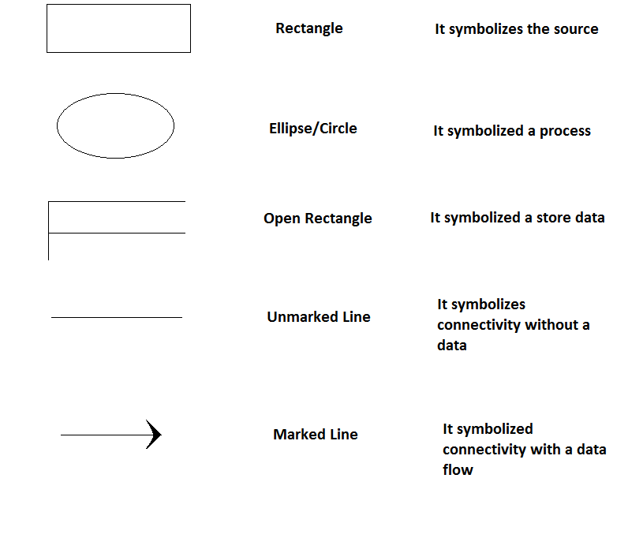

* ***Data Flow Diagram (lelvel 1)(USER):-***

User

ADMIN

User Personal Info.

Payment Info

User Info.

Product Price Info.

Product List

Product Cost

* ***Data Flow Diagram (lelvel 1)(ADMIN):-***

USER

ADMIN

Give order For Purchase info

Add Unavailable Product

Product List

Product Cost

level 1 DFD:

**ACCOUNT**

**Updation**

**3.**

**Admin**

View

Update Info.

Users

User Info.

Reports

Remaining Produts

Unregistered user

Private info.

Create Account

Product Info.

Registered user

**PURCHASE**

**2.**

VIEW

Info.

Info.

Inquiry